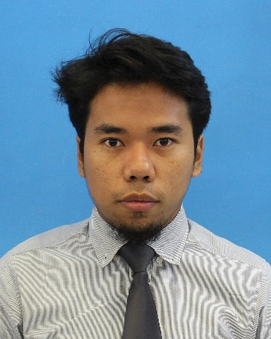**Muhammad Hafiz Bin H. Saharuddin  
Availability – February 2017 – May 2017**

Lot 33124, Jln Mawar Putih,

Kg Abu Bakar Baginda,

Bandar Baru Bangi,

43650, Selangor.

hfz_sahar@yahoo.com

+601123101120

**Education**

**Universiti Tenaga Nasional, UNITEN. September 2013 – September 2017**• Bachelor’s of Electrical and Electronic Engineering (Hons.)  
• Cumulative GPA : 2.61

**Non - Academic Experience**

* High Committee Kelab Kembara & Rekreasi, Universiti Tenaga Nasional – June 2015 – Present
* Badminton Club Member, Universiti Tenaga Nasional – September 2013 - Present
* High Committee Persatuan Pengajian Islam, Universiti Tenaga Nasional – May 2013 – Present
* Rowing Club Member, Universiti Tenaga Nasional – September 2013 – December 2014
* Kelab Kadet Bomba – S.M.K Putrajaya Presint 8 January 2007 - December 2011
* High Committee Kelab Pencinta Alam, S.M.K Putrajaya Presint 8 – January 2007 - December 2011
* Kelab Sukan Air, S.M.K Putrajaya Presint 8 – January 2009 – December 2011

**Additional Experience**

* Hiking Expeditions – Trans Titiwangsa V1 (5 days), Trans Titiwangsa V2 (8 days), Ekspidisi Rinjani, Lombok (6 days) – 2015 - 2016
* “Nuang Get Fit”, “Journey to Mt. Ledang”, “Discover Cemerung-Berembun-Langsir”, Organized by K.A.R.EN Universiti Tenaga Nasional – April 2015 - Present
* White Water Rafting Expeditions – Slim River, Perak & Sungai Nenggiri, Kelantan – 2014
* “Rock Conquest” – Gua Batu Damai, Batu Caves & Putrajaya Challenge Park, Putrajaya. ­– 2015
* “Program Hutan Sosial Korbu” – Gunung Korbu – 2015 & 2016
* Community Service at Temerloh, Pahang under Unicomserv, Universiti Tenaga Nasional – April 2015
* Community Service at Temerloh, Pahang with IKRAM – January 2015
* Zoo Negara Volunteering Program, Universitiy Tenaga Nasional - January 2015
* “Uniten Interclub Netball Tournament” – 2nd place Organized by Netropers Uniten – November 2016

**Skills**

• Fluent in English and Malay (both written and spoken).

• Proficient with Microsoft Word, Excel, PowerPoint and OpenOffice applications.

• Well exposed to Visual C++ (Visual Studio), LTSpice, ModelSim-Altera, Quartus II, Proteus, and MPLab.

• Enjoy indoor/outdoor sports, particularly hiking, badminton, football and track and field activities.

• Actively organize weekly outdoor activities such as hiking, wall climbing and rock climbing.

• Regularly participates in volunteer and charity work.